Sardar Vallabhbhai Patel

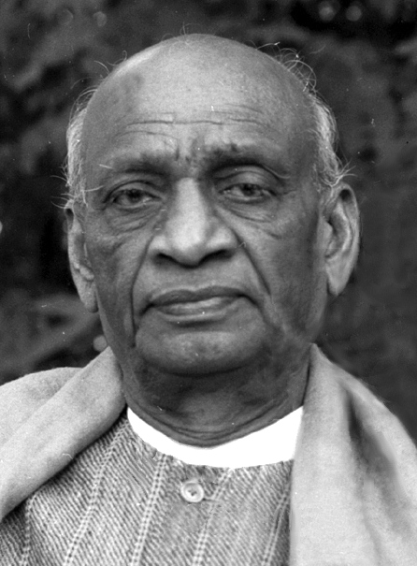
Born | Vallabhbhai Jhaverbhai Patel  31 October 1875  Nadiad, Bombay Presidency, British India
Died | 15 December 1950 (aged 75)  Bombay, Bombay State, India
Vallabhbhai Jhaverbhai Patel commonly known as Sardar, was an Indian lawyer, influential political leader, barrister and statesman who served as the first Deputy Prime Minister of India and first Home Minister of India from 1947 to 1950. The Statue of Unity, the world's tallest statue which was erected by the Indian government at a cost of USD420 million, was dedicated to him on 31 October 2018 and is approximately 182 metres (597 ft) in height. He was a barrister and a senior leader of the Indian National Congress, who played a leading role in the country's struggle for independence, guiding its integration into a united, independent nation. He was one of the conservative members of the Indian National Congress. In India and elsewhere, he was often called Sardar, meaning "chief" in Hindi, Urdu, Bengali and Persian. He acted as the Home Minister during the political integration of India and the Indo-Pakistani War of 1947.
Patel was born in Nadiad, Kheda district, and raised in the countryside of the state of Gujarat. He was a successful lawyer. One of Mahatma Gandhi's earliest political lieutenants, he organised peasants from Kheda, Borsad, and Bardoli in Gujarat in non-violent civil disobedience against the British Raj, becoming one of the most influential leaders in Gujarat. He was appointed as the 49th President of Indian National Congress, organising the party for elections in 1934 and 1937 while promoting the Quit India Movement.
As the first Home Minister and Deputy Prime Minister of India, Patel organised relief efforts for partition refugees fleeing to Punjab and Delhi from Pakistan and worked to restore peace. He led the task of forging a united India, successfully integrating into the newly independent nation those British colonial provinces that formed the Dominion of India. Besides those provinces that had been under direct British rule, approximately 565 self-governing princely states had been released from British suzerainty by the Indian Independence Act of 1947. Patel persuaded almost every princely state to accede to India. His commitment to national integration in the newly independent country was total and uncompromising, earning him the sobriquet "Iron Man of India". He is also remembered as the "patron saint of India's civil servants" for having established the modern All India Services system.

Deputy Prime Minister of India
The deputy prime minister of India is the second highest ranking minister of the Union in the executive branch of the Government of India and is a senior member of the Union Council of Ministers. The office holder also deputises for the prime minister in their absence.
The office has since been only intermittently occupied, having been occupied for a little more than 10 years out of the 75 years since its inception. Since 1947 India has had 7 deputy prime ministers, of which none having at least one full term. The first was Vallabhbhai Patel of the Indian National Congress party, who was sworn in on 15 August 1947, when India gained independence from the British Raj. Serving until his death in December 1950, Patel remains India's longest-serving deputy prime minister. The post was vacant until Morarji Desai became the second deputy prime minister in 1967 and has the second-longest tenure. Morarji Desai and Charan Singh were the deputy prime ministers who later became Prime Minister of India. Jagjivan Ram and Yashwantrao Chavan became deputy prime ministers consecutively without the break in different ministries. Devi Lal is the only deputy prime minister to represent both parties in the same post. Lal Krishna Advani was the seventh and last person to serve as the deputy prime minister of India until the post became vacant.

Statue of Unity
The Statue of Unity is the world's tallest statue, with a height of 182 metres (597 feet), located in the state of Gujarat, India. It depicts Indian statesman and independence activist Vallabhbhai Patel (1875–1950), who was the first deputy prime minister and home minister of independent India and an adherent of Mahatma Gandhi. Patel was highly respected for his leadership in uniting 562 princely states of India to form the single Union of India. The statue is located in Gujarat on the Narmada River in the Kevadiya colony, facing the Sardar Sarovar Dam 100 kilometres (62 mi) southeast of the city of Vadodara.
The project was first announced in 2010, and construction started in October 2013 by Indian company Larsen & Toubro, with a total construction cost of ₹27 billion (US$422 million). It was designed by Indian sculptor Ram V. Sutar and was inaugurated by the Prime Minister of India, Narendra Modi, on 31 October 2018, the 143rd anniversary of Patel's birth.
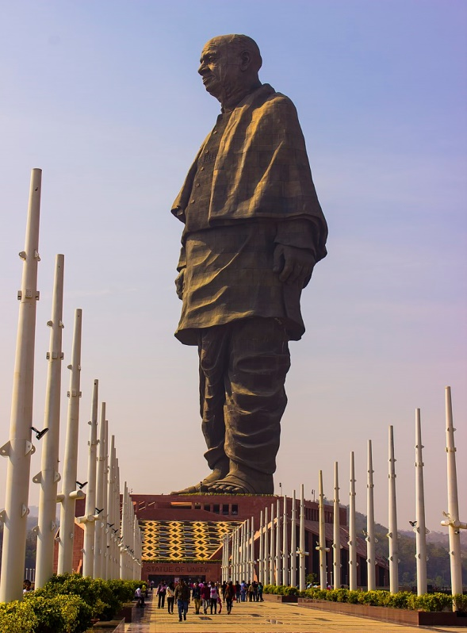

List of presidents of the Indian National Congress
The President of the Indian National Congress is the chief executive of the Indian National Congress (INC), one of the principal political parties in India. Constitutionally, the president is elected by an electoral college composed of members drawn from the Pradesh Congress Committees and members of the All India Congress Committee (AICC). In the event of any emergency because of any cause such as the death or resignation of the president elected as above, the most senior General Secretary discharges the routine functions of the president until the Working Committee appoints a provisional president pending the election of a regular president by the AICC. The president of the party has effectively been the party's national leader, head of the party's organisation, head of the Working Committee, the chief spokesman, and all chief Congress committees.
After the party's foundation in December 1885, Wyomesh Chandra Banerjee became its first president. From 1885 to 1933, the presidency had a term of one year only. From 1933 onwards, there was no such fixed term for the president. During Jawaharlal Nehru's premiership, he rarely held the Presidency of INC, even though he was always head of the Legislative Party. Despite being a party with a structure, Congress under Indira Gandhi did not hold any organisational elections after 1978. In 1978, Gandhi split from the INC and formed a new opposition party, popularly called Congress (I), which the national election commission declared to be the real Indian National Congress for the 1980 general election. Gandhi institutionalised the practice of having the same person as the Congress President and the Prime Minister of India after the formation of Congress (I). Her successors Rajiv Gandhi and P. V. Narasimha Rao also continued that practice. Nonetheless, in 2004, when the Congress was voted back into power, Manmohan Singh became the first Prime Minister not to be the president of the party since establishment of the practice of the president holding both positions.
A total of 61 people have served as the president of the Indian National Congress since its formation. Sonia Gandhi is the longest serving president of the party, having held the office for over twenty years from 1998 to 2017 and from 2019 to 2022.

Quit India Movement
The Quit India Movement, also known as the August Kranti Movement, was a movement launched at the Bombay session of the All India Congress Committee by Mahatma Gandhi on 8th August 1942, during World War II, demanding an end to British rule in India.
After the failure of the Cripps Mission to secure Indian support for the British war effort, Gandhi made a call to Do or Die in his Quit India speech delivered in Bombay on 8 August 1942 at the Gowalia Tank Maidan. The All India Congress Committee launched a mass protest demanding what Gandhi called "An Orderly British Withdrawal" from India. Even though it was at war, the British were prepared to act. Almost the entire leadership of the Indian National Congress was imprisoned without trial within hours of Gandhi's speech. Most spent the rest of the war in prison and out of contact with the masses. The British had the support of the Viceroy's Council (which had a majority of Indians), of the All India Muslim League, the Hindu Mahasabha, the princely states, the Indian Imperial Police, the British Indian Army, and the Indian Civil Service. Many Indian businessmen profiting from heavy wartime spending did not support the Quit India Movement. Many students paid more attention to Subhas Chandra Bose, who was in exile and supporting the Axis Powers. The only outside support came from the Americans, as President Franklin D. Roosevelt pressured Prime Minister Winston Churchill to give in to some of the Indian demands. The Quit India campaign was effectively crushed. The British refused to grant immediate independence, saying it could happen only after the war had ended.
Sporadic small-scale violence took place around the country and the British arrested tens of thousands of leaders, keeping them imprisoned until 1945. In terms of immediate objectives, Quit India failed because of heavy-handed suppression, weak coordination and the lack of a clear-cut programme of action. However, the British government realised that India was ungovernable in the long run, and the question for the postwar era became how to exit gracefully and peacefully.

All India Services
The All India Services (AIS) comprises the Indian Administrative Service, Indian Police Service and Indian Forest Service. A unique feature of the All India Services is that the members of these services are recruited by the centre (Union government in federal polity), but their services are placed under various State cadres, and they have the ability to serve both under the State and under the centre. Due to the federal polity of the country, this is considered one of the tools that makes union government stronger than state governments. Officers of these three services comply to the All India Services Rules relating to pay, conduct, leave, various allowances etc.
The All India Services Act, 1951, provides for the creation of two more All India Services, namely, the Indian Engineering Service and the Indian Medical Service.
The Ministry of Personnel, Public Grievances and Pensions is the cadre controlling authority for the Indian Administrative Service, The Ministry of Home Affairs is the cadre controlling authority for the Indian Police Service and the Ministry of Environment, Forest and Climate Change for the Forest Service. The examination for recruitment of IAS and IPS is conducted by the Union Public Service Commission (UPSC) on the basis of the annual Civil Services Examination, a common civil service examination, and for the Indian Forest Service on the basis of the Forest Service Examination. Since 2012 onwards, the preliminary (first test) of the two examinations are combined. These officers are recruited and trained by the Central Government, and then allotted to different State cadres.

